README

Create a normal react-native application with the name of the app called Polarscene.

Then insert the files and folders from the zipped folder that we have submitted here into the Polarscene app folder that you created:

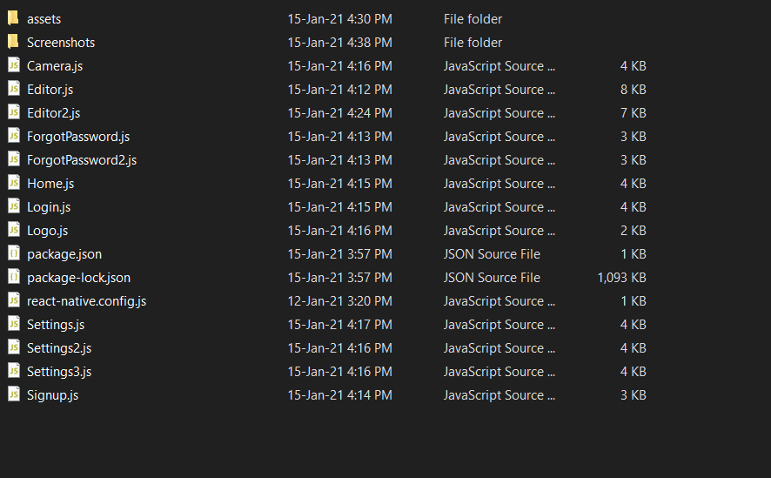

As the package.json and package-lock.json files are there, all you need to do to have all the dependencies is to type npm install like this:

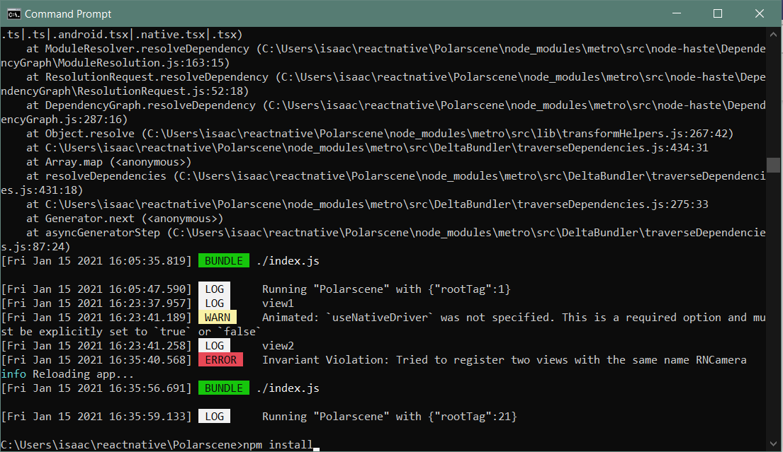

Then after that, run react-native link. See the last line of the command promp in the screenshot below.

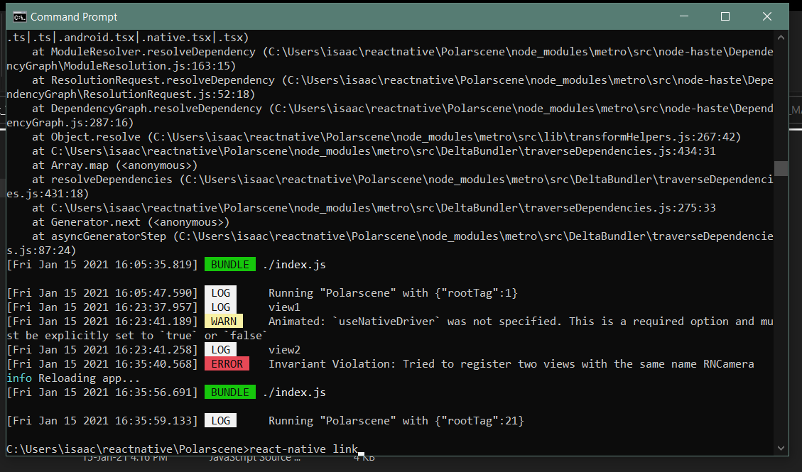

Then there is some set up to be done In Android Studio due to the Camera.

App -> manifests -> AndroidManifest.xml

Add these lines of codes

*<!-- Camera Permission -->*

<**uses-permission android:name="android.permission.CAMERA"** />

*<!-- include this only if you are planning to use the camera roll-->*

<**uses-permission android:name="android.permission.READ_EXTERNAL_STORAGE"** />

<**uses-permission android:name="android.permission.WRITE_EXTERNAL_STORAGE"** />

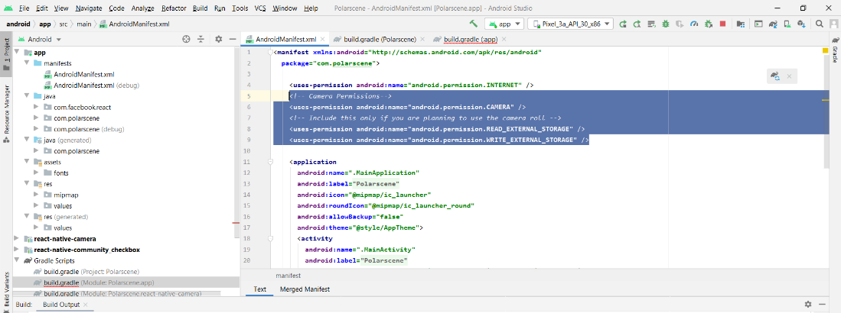

Gradle Scripts -> build.gradle(Module:Polarscene.app)

Add this line of code in defaultConfig

missingDimensionStrategy **'react-native-camera'** , **'general'** *// <-- insert this line*

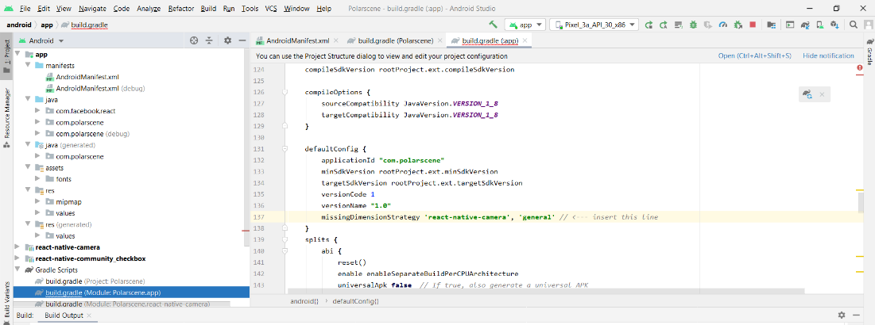

To see each of the pages, insert the code of each js file into the App.js file and run it.